……….
30723 Sodaville Rd Lebanon, Oregon
January 2020 Volume 1 Issue 1

City Hall (541) 258-8882 Mayor Suzie Hibbert email: sodaville@cityofsodaville.org
Web Address: www.sodaville.org Judy Smith – City Administrator
000000000000…………..000000000000000000000000000000

City Council Meeting City Hall Hours
7:00 pm January 16, 2020 Mon. – Thurs. 10 am – 2 pm
CITY UPDATE
Happy 2020! Hopefully everyone is having a good year so far and had wonderful Holidays. As of now, the Water Restriction has been lifted!! No more restriction on water usage does not mean a free for all however. Those that have lived in this city for a long time can tell you that drought conditions come on quick and the more conservation efforts made the longer the time before restriction is implemented again. This has been a fairly dry winter which does not make for good forecasts on the wells come summer. The City has a couple of projects in the works to help in the future, but it is highly doubtful that either will be completed this year. I hate to say it, but rain, rain and more rain will help the most. (I am not a fan of rain as you can tell). Hope everyone has a fantastic New Year!

Sodaville History:

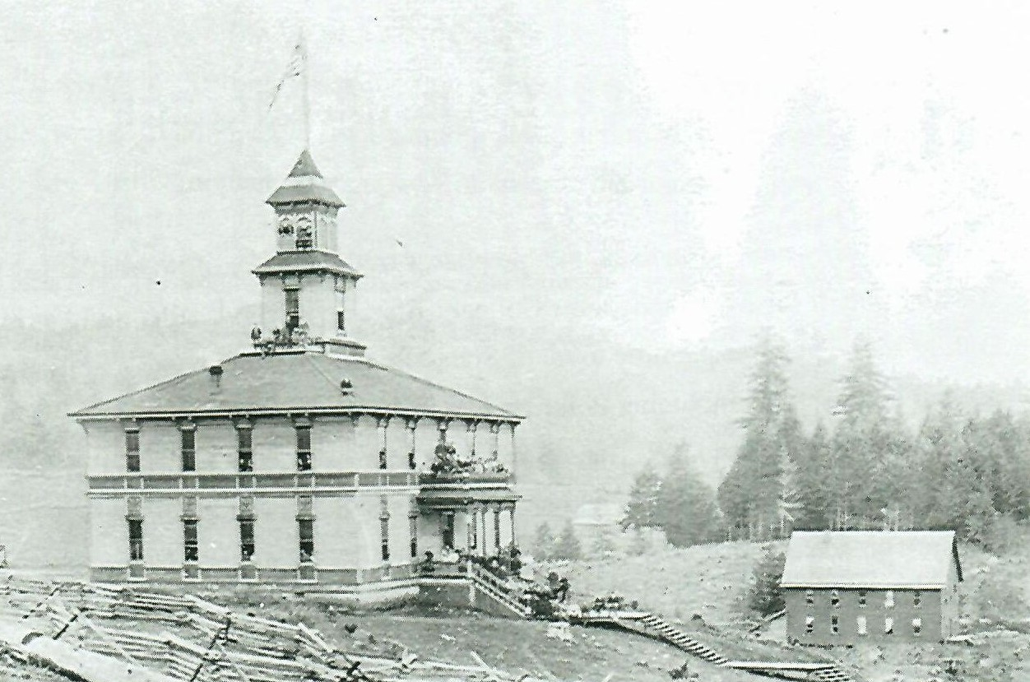
The Mineral Springs College Building was built in 1892 and closed in 1907-08. In 1909 School District 13 bought the building and used it for an elementary school for 40 years. It was razed in 1949 and the first building of the current school was erected. Note the ﬂag ﬂying from the highest peak of the building. This was a job for the boys in the school to climb up in the belfry and raise the flag. In later years, the belfry was condemned and a flag pole was erected.
The building in the lower right of the picture was built for the women’s’ dormitory after the college was erected. This building was moved to Crowfoot and has been the Crowfoot Grange Hall for many, many years. The building was placed on skid logs, and with lots of help, it was moved. They used many small logs and as it was pulled, someone would move the small logs to the front. Hence, it was rolled to the new site. They used several teams of horses. The moving took place about 1914.

Judy Smith, City Administrator
MAYOR’S MESSAGE
January 2020!! It’s a brand new decade and you are seeing it from the beginning! The roaring 20’s has got nothing on us! So it is time for a fresh beginning 2020. When you see Councilor Ray Jackman around, say thank you for the superb job with the New Year’s Eve Fireworks. What a magnificent way to bring in the New Year. So a big thank you to you and you crew.

Lots of new things are coming our way and we’ll need your help and cooperation to get these things done smoothly. Make it fun. Join the Citizens Planning Committee. Be brave, come see what’s next. The next meeting is Thursday 1/16/20 @ 6:15pm at City Hall. We do have a Celebration party to plan for this Spring. I’m sure we can think of something else to do also. I really want to make the things we come up with, come to fruition. I can only push it so far, I cannot do it alone, although I try.
Come watch the City Council meeting and pay attention to the new changes. 1.16.20 @7pm

Remember to wrap your pipes from the cold freeze that will be coming. You know it will, we tend to say nah, we don’t get that kind of weather. Then we do. SNAP! Your pipe is frozen and blowing water everywhere.

Take care you yourself and your neighbor should they need anything. Don’t be afraid to say anything. Speaking of watching out for things, we had some things stolen, it was a quick grab. He was caught thank goodness, before we even knew our things were stolen. Thank you to the Lebanon Police Department for being on top of the game. Let’s keep Sodaville safe by paying attention to who is walking out your neighborhood.

Take care and stay safe

Suzie mayorhibbert@gmail.com

Public Works Newsletter
2020 is finally here and with it we are all starting to see some rain. The City's reservoir is currently more than two-thirds full. What does that mean for you? That means the restriction that has been in place since July 2019 is over. However, 2019 proved to be a very dry year and continued conservation efforts are needed in 2020. Continued conservation efforts will help to postpone another restriction next summer.

The City of Sodaville is not alone in its water woes! Several Cities along the Oregon Cascades experienced water shortages in 2019. It's becoming the “new normal” for those Cities relying on wells for their water. Please conserve water whenever you can.

Stan Smith, Public Works Director

Country Girl Quilting
*Long-arm Machine Quilting
Call Sharon Hill and Joleana Altom at 541-401-7936
Carries Country Inn Adult Foster Home
is located at 30785 Washington Street in Sodaville. “A safe, comfortable home
where you can keep your dignity, respect and independence.”
For information call: 541-570-1430
If you have any announcements, information or ads you wish to have published in the newsletter, please call before the 6th of the month and I will be happy to insert them! “The City of Sodaville is an equal opportunity provider and employer.”

