……….
30723 Sodaville Rd Lebanon, Oregon
December 2018 Volume 12, Issue 18

City Hall (541) 258-8882 Mayor Suzie Hibbert email: sodaville@cityofsodaville.org
Web Address: www.sodaville.org Judy Smith – City Administrator
000000000000…………..000000000000000000000000000000

City Council Meeting City Hall Hours
7:00 pm December 20, 2018 Mon.–Thurs. 10 am–2 pm
CITY UPDATE

city hall and public works will be closed DECEMBER 24 - december 26TH and december 31 - January 1, 2019
Projects in the City are moving along. Vine Street is awaiting paving, the park is awaiting septic approval, and Well #6 will be starting the 72 hour testing. Below is another small “History” of the City of Sodaville. This month is the Mineral Spring Park (City Hall Park):
SPRING PRESERVATION The movement to preserve the spring came first from the pioneers themselves. They built a rail pen around it. This kept the cattle out but not the deer. Then the rails were replaced by a board fence. Later a local man built an open shed over the spring, octagonal in shape, with seats around the inside. The floor was brick and the water was dipped from bricked-up shallow wells. Milton A. Miller secured the first help from the state, an appropriation by the legislature for improvements in 1891, and the building was put up, though not completed until ten years later. More money for repairs and improvements was secured in 1901 and 1920. The legislature in 1947 turned the property over to the state highway commission and the department of state parks. It was the first Oregon State Park. Mineral Springs Park was deeded to the City of Sodaville in 1972.Below are photos of the original Spring Hall built in 1901. The aging Sodaville Mineral Spring Hall was torn down in January 1970. City Hall now stands there. The cistern for catching the spring water is beneath.
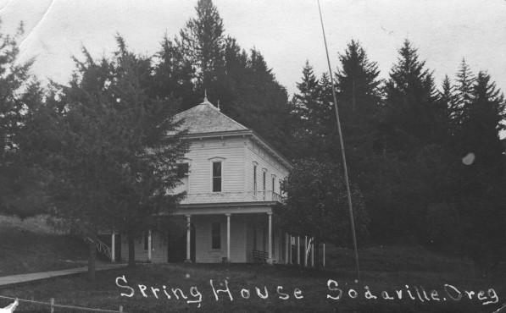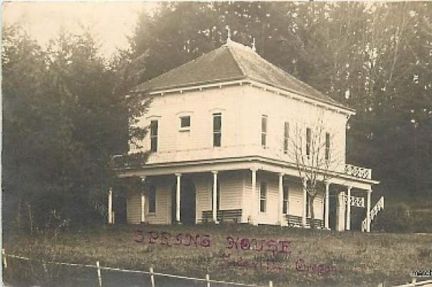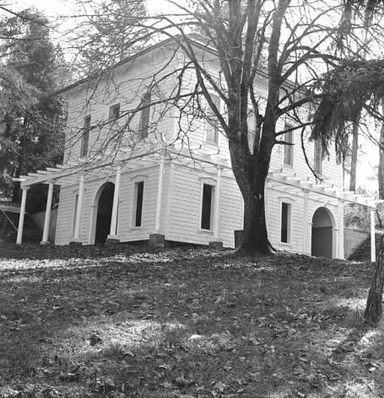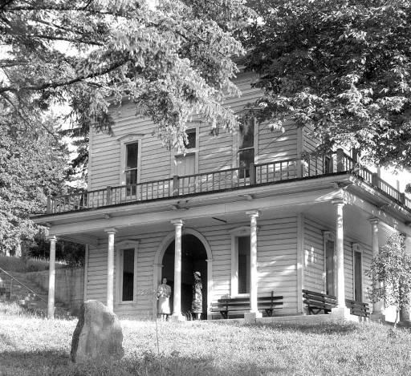
Speaking of the park, the Citizen Planning Committee is still looking for decorations to dress up the park for the Holidays. If you have any lights or yard ornaments, please drop them at City Hall! All donations are welcome.
Merry Christmas and Happy New Year,
Judy Smith, City Administrator

MAYOR’S MESSAGE
Ah December! The best month of the year. We all show how we care for each other, as the Holiday Cheer.

The Citizens Committee is trying to show how they care for the City by gathering as many Christmas Lights as possible to light up the City Park. They could use your donations of any decorations you have available to give. As you know, we are slowly but surely trying to improve the City in as many ways as possible. What you may not know, or remember, the City’s decorations were stolen from the park a couple of years ago. Let’s protect our City as we try to improve it and keep it protected afterwards. If you see something illegal ie: destructive or people spending the night in the park, please report it the Linn County Sheriff’s Office. They are the only ones who can truly take care of the problem. If you do not want to make the effort in doing so, take a video of it with the timestamp and location for additional proof. Either Call the Sheriff or email a video to the city or I’m sure any of your councilors would be willing to make the call. And I would think you know at least one of your councilors number. Do not let a Grinch spoil your park.

Isn’t the rain a welcome sight!? We are STILL on water restrictions, so please never curse the rain...haha

Merry Christmas Sodaville!!

Take care and I’ll see you around,

Suzie mayorhibbert@gmail.com

Public Works Newsletter
The current drought that caused the City of Sodaville's water shortage looks to be over and the rain is once again falling over our little part of Oregon. That does not mean that the water situation is better at this time. The current water restriction is still in effect and may remain in effect until rain water reaches the aquifers that feed the wells. It takes a good month of rain to get the City's wells back to where they can produce enough water to support the City's needs. Please continue to conserve water where ever you can.

The Vine Street Project is finally under way. So far the road has been widened. Next, the Spring Street end will be leveled off. More gravel will be laid down and compacted and with any luck the road will be paved by the end of the year.

The City of Sodaville Public Works Department would like to wish everyone Merry Christmas and a Happy New Year. Stay safe if you travel during the holidays.

Stan Smith, Public Works Director

Country Girl Quilting
*Long-arm Machine Quilting
Call Sharon Hill and Joleana Altom at 541-401-7936
Carries Country Inn Adult Foster Home
is located at 30785 Washington Street in Sodaville.
“A safe, comfortable home where you can keep your
dignity, respect and independence.”
For information call: 541-570-1430

If you have any announcements, information or ads you wish to have published in the newsletter, please call before the 6th of the month and I will be happy to insert them! “The City of Sodaville is an equal opportunity provider and employer.”

