……….
30723 Sodaville Rd Lebanon, Oregon
June 2018 Volume 6, Issue 18

City Hall (541) 258-8882 Mayor Suzie Hibbert email: sodaville@cityofsodaville.org
Web Address: www.sodaville.org Judy Smith – City Administrator
000000000000…………..000000000000000000000000000000

City Council Meeting City Hall Hours
7:00 pm June 21, 2018 Mon.–Thurs. 10 am–2 pm

CITY UPDATE

City Hall will be closed on Thursday, June 7
There will be a PUBLIC HEARING regarding the Fiscal Year 2018-2019 Budget at the June 21st Council Meeting.
Also at that meeting will be the decision on the Soda Springs Community Center Park Project. Bids will be evaluated and the Council will determine who will receive the work. Audit RFP submissions will also be reviewed and an Auditor will be chosen to perform the City audits for the next 3 years.
Volunteers will be needed once the Soda Springs Community Center Park Project starts. The City has a grant match of $45,000. All donations including machinery and volunteer hours will count toward that match. Some of the projects the City will take on is landscaping, building the children’s playground and overall help on the project. If you are interested and would like an email with the details when the project starts, contact City Hall or go to the website www.sodaville.org . I will try to keep the site updated with the latest dates and times.

Judy Smith, City Administrator
MAYOR’S MESSAGE
June is here! Strawberry season is one of my favorite reasons to love June. What’s yours?

The City is cruising along with getting bids to finally get started on the Soda Springs Park Project. We’ll know which contractor is going to get started on the park, at the June Council meeting. Bids will be opened and awarded that night.
The fence for the sport court is still waiting to be installed. The Council simply cannot do it all. We need your help. I’ve gotten a basic detailed rundown of what needs done. If you can do any part of it please contact Stan by leaving a message for him at City Hall, 541-258-8882 and he’ll be glad to get together with you.
For the fence to go up around the Sport court, these things need to be complete-
*Bring down one more piece of pipe and cut it. We are repurposing the pipe from the Wells Rehabilitation Project we did in 2016.
*Remove the sleeves on the pipe It’s a two man job to get those off.
*Each piece of pipe must have the galvanized material removed near where it is to be welded. This is for safety purposes as that material can be deadly when welding.
*We need to have someone with a welder to weld them in place.
*Put brackets on the posts, add the horizontal bracing at the top and in the middle of the posts.
*Paint the posts.
*Add the fencing to posts, we’ll all get together and finish it up! Lunch will be provided that day!
AVAILABLE TO HELP??
The Citizens Committee is small, although we do have a few more people join us, of which thrills us! Sad to say though, that there weren’t enough people to get the float put together. I hate saying we’ll do something then back out. This is your city, your community. Don’t you want to see it come together? Wouldn’t you like to be proud to say, Yes, I live in Sodaville and we have a great time together! I do. See you Thursday 6 pm, June 21st. @ City Hall.
It would be wonderful if we could keep the restroom open at the park. Every time we do, the bathroom gets thrashed with disgusting filth all over the walls. If you know anyone who is possibly destroying your city property and taking away your ability to enjoy the park after Stan’s work hours, please do something. Report them to the Linn County Sheriff’s Office and help us get this stopped.

Be a part of the greater good in Sodaville,

Suzie
Mayor Suzie Hibbert mayorhibbert@gmail.com

Public Works Newsletter
As you may know the City of Sodaville received a grant from the Oregon Parks and Recreation Department for $225,000. The grant is to be used for our new park on Main Street and Sodaville Road. The bidding process is underway and all bids will be opened publicly on June 21, 2018 at 2:00 pm. At 7:00 pm bids will be submitted to the City Council for review.
The Grant breaks down like this. $180,000 will come directly from the OPRD. $45,000 or 20% of the total cost will come from “in kind” work from City staff and volunteers. In kind work eliminates the cost burden for the City and allows the project to be completed without draining the City's budget. The Citizen Planning Committee has been working to plan the project and insure that what is installed in the new park is what they want and need. Some of the projects like the horseshoe pits are the responsibility of City Staff and volunteers. Other projects are shared like the children's playground. The contractor will purchase the playground and volunteers and City staff will install it. Other projects like the parking area will be done by the contracting company awarded the project. The OPRD set up their grants to allow small Cities like Sodaville to have the opportunity to have something they need and make it affordable, but we need your help to make it work. Once construction begins, set aside a day or a few hours of time to come help out. If you have equipment that may be helpful in completing a project bring it on down and help out. What we need. Volunteers, materials, equipment such as tractors, post hole diggers, backhoes, trailers for moving rock and dirt. Let’s make this a true community effort that you can enjoy for years to come. If you would like to volunteer or become a member of the Citizen Planning Committee please call 541-401-8537 and talk to the Public Works Director or you can show up at the Citizen Planning Committee meeting on the third Thursday every month at 6:00 pm.

Just a reminder, to keep tall grass down during the spring and summer months. Please keep tall grass and weeds down around your meter boxes as well. For meter boxes keep an area of at least 2' on each side of the box clear. This is important for the meter reader’s safety as they can't see large rocks and other obstacles through the tall grass which may result in injury.

Stan Smith, Public Works Director
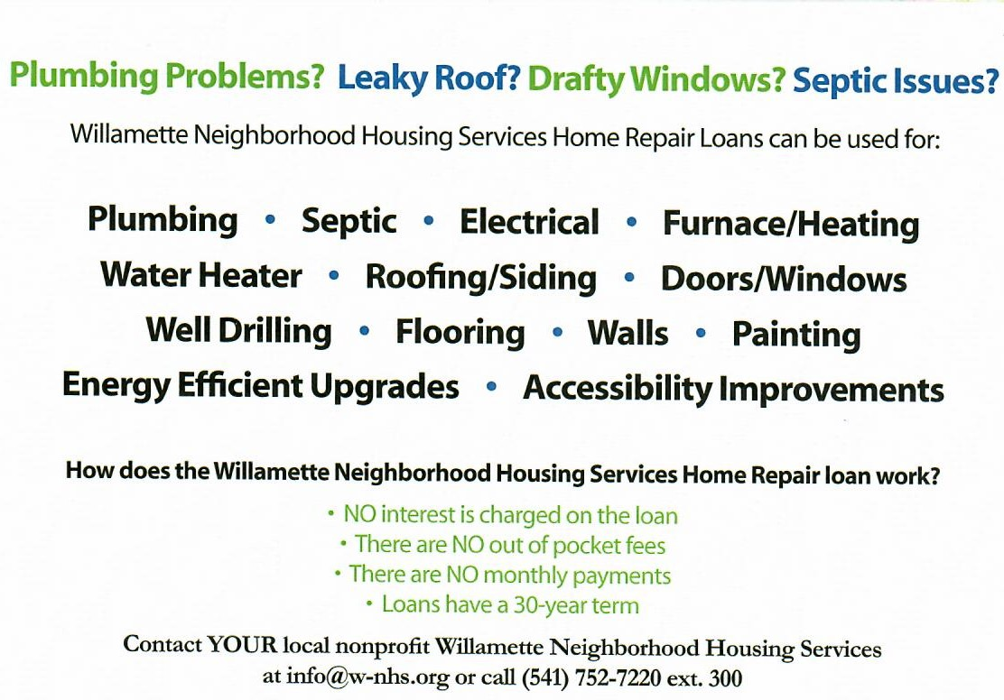

Country Girl Quilting
*Long-arm Machine Quilting

Call Sharon Hill and Joleana Altom at 541-401-7936
Carries Country Inn Adult Foster Home

is located at 30785 Washington Street in Sodaville.
“A safe, comfortable home where you can keep your
dignity, respect and independence.”
For information call: 541-570-1430

If you have any announcements, information or ads you wish to have published in the newsletter, please call before the 6th of the month and I will be happy to insert them!
“The City of Sodaville is an equal opportunity provider and employer.”

