……….
30723 Sodaville Rd Lebanon, Oregon
October 2017 Volume 10, Issue 17

City Hall (541) 258-8882 Mayor Suzie Hibbert email: sodaville@cityofsodaville.org
Web Address: www.sodaville.org Judy Smith – City Administrator
000000000000…………..000000000000000000000000000000

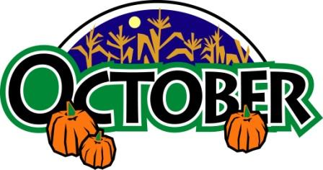
City Council Meeting City Hall Hours
7:00 pm October 19th, 2017 Mon.–Thurs. 10 am–2 pm
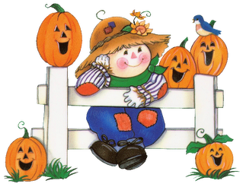
CITY UPDATE

At the September 21st City Council meeting, a Public Hearing was held regarding Ordinance #17-01 AN ORDINANCE SETTING MUNICIPAL FEES AND UTILITY SERVICE RATES AND CHARGES IN ACCORDANCE WITH THE FEES, RATES AND CHARGES ORDINANCE #02-03, #91-3 and #91-4. The Ordinance was passed unanimously. As of October 1, 2017, water rates and some other fees will increase. The base rate of $35.00 per month will now be $45.00 per month and includes the first 2,500 gallons. There will be an increase in the tiers also. The cost of keeping the system operating has gone up. Electricity rates have increased, cost for pipe, valves, meters, etc. have become more expensive. There are improvements and maintenance in the future that will have to be completed. The Water Rate Study by Rural Community Assistance Corporation (RCAC) identified the need for the increase and recommended the amounts necessary to meet that need. A matrix that included the capital assets of the water system along with the life span of each part was reviewed. To be able to provide repairs or replacements when necessary an increase had to be put in place. Currently the system income to costs was just about breaking even. This does not allow for any monies to be saved toward the impending repairs, maintenance or emergencies. The new increase will show up on water bills with the November billing cycle.

Watch out for the little ones who will be Trick or Treating! Remember, all of the streets are at a 25 mph speed limit!

Judy Smith, City Administrator

MAYOR’S MESSAGE
Hello Fall! This season is a favorite. October is my birthday month and everything is just pretty and crisp. Hot Apple Cider, Popcorn balls and Candy corn. German Chocolate cake and Pecan pie are a few of my favorites...
Water rates have gone up in order to finish this project of having enough water to fully supply the city year round for years to come, along with costs to run the system. We are getting nearly a million dollars for this project of which we will have to repay about a quarter of that at only 1% inerest. If the rates had not gone up to compensate, then we would not have been able to accept the Grant. The project would not have happened.
We have received yet another Grant for the Soda Springs Park $225,000. We really need to get your input on details for the improvements. Councilor Anthony Morales is now heading up the Citizens Committee. He has fresh ideas and lots of experience. Come join in. It is the same night as the Council meeting, 3rd Thursday of each month @ 6 pm.
Take care! See you around,

Suzie Hibbert, Mayor mayorhibbert@gmail.com

Public Works Newsletter

I would like to thank everyone for your efforts in conserving water this year. Although it is typical for the City of Sodaville to use above 700,000 gallons a month this time of year the readings indicate usage of about 550,000 gallons. Reduced usage has helped to keep the City’s Reservoir nearly full at the beginning of October. Some of the City’s wells are struggling but our best producer is still delivering water normally. Please continue to conserve water until we see at least two weeks of rainfall in the region.

As you may already know the City of Sodaville has received a grant from the OPRD (Oregon Parks and Recreation Department) in the amount of $180,000. The City has a match amount of $45,000 for a total of $225,000. The City’s match amount will mostly come from donated time, materials and equipment. Volunteers are needed for planning and implementing various projects related to the new park. The Citizen Planning Committee is in need of members for this project. If you would like to be a part of the planning process or would like to volunteer for certain aspects of the development of the park please call City Hall at 541-258-8882. Work on the new park is expected to start early next spring and must be completed by October 31, 2019.

Stan Smith, Public Works Director

Country Girl Quilting
*Long-arm Machine Quilting

Call Sharon Hill and Joleana Altom at 541-401-7936

Carries Country Inn Adult Foster Home

is located at 30785 Washington Street in Sodaville.
“A safe, comfortable home where you can keep your
dignity, respect and independence.”

For information call: 541-570-1430

If you have any announcements, information or ads you wish to have published in the newsletter, please call before the 6th of the month and I will be happy to insert them!

“The City of Sodaville is an equal opportunity provider and employer.”

