……….
30723 Sodaville Rd Lebanon, Oregon
April 2017 Volume 4, Issue 17

City Hall (541) 258-8882 Mayor Suzie Hibbert email: sodaville@cityofsodaville.org
Web Address: www.sodaville.org Judy Smith – City Administrator
000000000000…………..000000000000000000000000000000

City Council Meeting City Hall Hours
7:00 pm April 20th, 2017 Mon.–Thurs. 10 am–2 pm

CITY UPDATE
Just a reminder, City Hall will be closed May 1 to May 5 and will reopen May 8. I will be in Pennsylvania visiting family but I will have my cell phone and laptop for questions or emergencies. I will be returning voice messages to the city along with email while I am gone. Public Works Director Stan Smith will be around town, it is difficult if both of us are gone for an extended period of time.

On Thursday, April 20 at 6:00 pm, the City Council and Citizen Planning Committee will be holding a workshop to plan “goals” for the City over the next 5 years. This helps to determine what the main priorities for the city and citizens are so that planning and budgeting can be more productive along with seeking grant funding. Please attend if you have any thoughts or ideas as to where you would like the City to go in the future.

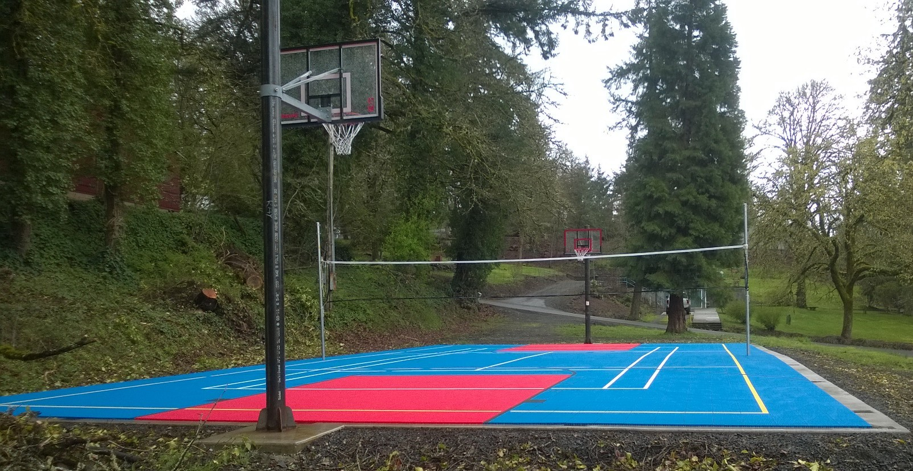
On Saturday March 4, citizens placed the tile for the Multi Use Sport Court. The basketball hoops and volleyball/tennis net are now up and in use!! It is exciting to see how many are already using the Court! The fencing will be next. A Dedication Ceremony will be held when the court is completed! The day and time will be posted. Thanks to Councilor Brian Lewis, Councilor Ray Jackman and everyone that volunteered for a great team effort!!
Judy Smith, City Administrator
MAYOR’S MESSAGE
Big things have happened already!!! I know when you are coming down the hill you can now spot the Soda Springs Community Center Park immediately! There is no missing it. The tile is now installed and the Basketball hoops and tennis/volleyball/badminton net will be installed by the end of this month. In the next month or so the fencing around court will be installed. THANK YOU to the volunteers who have helped in making this happen. We very much enjoy having your participation!
This is something we have wanted for you for well over a year now. Actually I have wanted this since we had SNIC (Sodaville Neighbors Improving Community, now defunct). We just didn’t have the space, or funds, to pursue it. Thankfully, we now have Judy Smith who is so innovative and knowledgeable. She is a guru at getting grants for the city. Having her is very encouraging for the Council to act on the improvements around town. The Council (current and prior) has been very productive in improving your/our town. I am very pleased with how everything is coming together. If you have any ideas in completing the grounds around the court please come to the Citizens Planning Committee at 6pm before each council meeting.
Meetings are continuing in our quest of getting the Water system up to the abilities of providing to and above our City’s/resident’s needs. Without water conservation being required or even requested.
Enjoy our new Sport Court!! Hope to see you down there!
Suzie Hibbert, Mayor mayorhibbert@gmail.com

Public Works Newsletter
After a very wet and cold winter, spring is finally here and the flowers are starting to bloom.
Every year in March the City of Sodaville is required to check the static levels of each of its five wells. Three of the City’s five wells show vast improvement over the winter months. The other two wells have had declining water levels for the past several years and have never produced much water. Please continue conservation efforts through the summer to insure there is enough water for normal usage.
The work on well six, the City’s new well is in the preliminary engineering phase and is proceeding as expected. At this point in time it is difficult to say when well six will go online and start producing water for the City.
The new “Sport Court” is now ready for use. Not everything is done but the basketball hoops and the volley ball/Tennis/Badminton net is up. The City is planning to put a fence around the sport court once the weather allows.
Special thanks go out to City Administrator Judy Smith for her work in securing the grant and purchasing all the equipment. Councilors Ray Jackman and Brian Lewis for their efforts to put it together rain or shine. The Citizen Planning Committee for their efforts in recruiting help and getting the site ready. And finally all of the volunteers and contributors that came out and did their part to make it all happen. It truly has been a community effort.
Stan Smith, Public Works Director
Country Girl Quilting
*Long-arm Machine Quilting

Call Sharon Hill and Joleana Altom at 541-401-7936
Carries Country Inn Adult Foster Home
is located at 30785 Washington Street in Sodaville.
“A safe, comfortable home where you can keep your
dignity, respect and independence.”

For information call: 541-570-1430
If you have any announcements, information or ads you wish to have published in the newsletter, please call before the 6th of the month and I will be happy to insert them! “The City of Sodaville is an equal opportunity provider and employer.”

